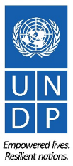
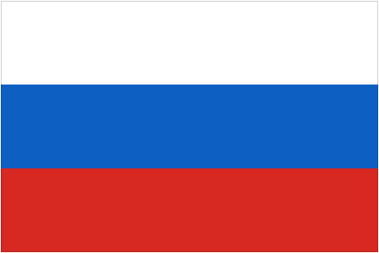
Knowledge Management and Capacity Development in Russia-UNDP Partnership
Regional Project, Phase III
RUSSIAN EXPERTS ON DEMAND PROGRAMME
CALL FOR PROPOSALS
Individual online consultancy

Since 2017 the Russian Experts on Demand programme under the regional project
’Knowledge Management and Capacity Development in Russia-UNDP Partnership’ (KM Project) has been serving as an instrument for assistance to UNDP programme countries in solving development challenges by sharing Russian hands-on experience, knowledge, and know-how via rapid deployment of Russian experts for on-demand small-scale interventions, consultancies, and peer-to-peer knowledge sharing. In Phase I and Phase II 96 individual and 3 institutional assignments were implemented.
The KM Project Phase III announces a new Call for Proposals and invites UNDP country offices (COs) to submit applications for financing.
High quality applications that stem from national demand and are in line with the Country Programme Document (CPD) should contain justifications of strong need in Russian expertise.
The Programme stays committed to supporting the Leaving No One Behind (LNOB) Principle by providing expertise for increasing the social inclusiveness of the people left behind or at risk to be left behind to eradicate poverty in all its forms, end discrimination and exclusion, and reduce the inequalities and vulnerabilities that leave people behind and undermine the potential of individuals and of humanity as a whole. The LNOB principle and the women empowerment approach will be applied during evaluation of applications. Thus, COs are kindly requested to duly consider LNOB principle as well as specific development needs of women and girls.
- Eligible Country Offices: Armenia, Azerbaijan, Belarus, Cuba, Kazakhstan, Kyrgyzstan, Lao PDR, Moldova, Serbia, Tajikistan, Turkmenistan, and Uzbekistan. In Phase III, the geography of the Programme is expanded and included Botswana, Cambodia, Guinea, Kenya, Madagascar, Syria, and Zimbabwe which are invited to apply for the Programme as well.
Considering the increase in the number of countries eligible to apply to the Programme it is strongly advised to limit the number of applications to maximum three from one CO.
- COs are invited to apply for online individual consultancies by individual expert under the small-scale assignment modality up to 20 working days over 3-4 months period (a longer period of up to 40 working days is possible if required).
The modality envisages desk work, online communications, and events via digital communication tools with provision of key outputs (e.g., small-scale feasibility studies, recommendations for government officials, trainings, workshops, contributions to conferences and various types of targeted technical consultations).
3. Priority areas for interventions (workshops, consultancies, and short-term advisory services) are:
- Trade capacity development and sustainable economic growth;
- Health safety; Infectious and non-infectious diseases, sanitary and epidemiological safety;
- Education quality;
- Food security and social protection;
- Disaster risk reduction and prevention;
- Hazardous-waste management;
- Sustainable energy, including energy efficiency;
- Public administration systems;
- Innovations, IT, and digital economy;
- Regional and area-based development;
- Environmental protection, combating climate change and its impacts;
- Entrepreneurship development;
- Sustainable transport systems;
- Gender mainstreaming;
- Volunteering development;
- Agriculture;
- Statistics;
- Others.
Offices should provide a narrative about effects of the intervention on social inclusiveness and women empowerment.
The list of Phase II assignments thematic areas is available on p.3 of the present document.
4. All assignments are tentatively expected to start in March-April 2022.
5. Available Russian Expertise
Applicants are highly encouraged to consult the Database of Russian experts at expertsfordevelopment.ru (over 290 profiles to date) for available individual expertise and specify the name of the expert from the Database or relevant institutions in the respective place of the application form. The KM Project team can provide assistance with identifying and locating relevant Russian experts if the Database does not cover the expertise on the required thematic area.
Applications with clear understanding of the source of expertise (from the database or outside) will be prioritized.
6. Proposals should include an application and a draft ToR. Documents should be submitted for evaluation before 28 February 2022 to: ksenia.chayka@undp.org, Cc: natalia.voronkova@undp.org.
7. The following criteria will be used to evaluate the applications:
1) Evidence of demand and alignment with CPD;
2) Relevance of Russian expertise;
3) Complementarity to current portfolio / no duplication (especially with other projects funded by the Russian Federation);
4) Application of LNOB principle and contribution to women empowerment.
Applications meeting a minimum of three criteria will be approved.
8. For the proposals received the following procedure will be applied:
  - Evaluation of proposals and notifying COs about funding decisions;
  - Finalization of ToRs by COs in cooperation with national partners and based on the comments by the KM Project team;
  - Recruitment process is performed by COs with advisory support from the KM Project team. For most assignments, simplified procedure of hiring individual consultants under $10,000. If the financial proposal of the qualified expert exceeds the amount $10,000, the ‘request for quotation’ procurement method should be applied. In this case, the timeline for implementation will be significantly extended. Please consult with your HR unit on the recruitment process.
If vacancy announcements are posted, COs are expected to share final ToRs with the KM Project team before posting. The KM Project team can assist in circulating vacancy announcements among relevant Russian experts;
  - In case of increased length and scope of work of the assignments, COs are encouraged to co-fund the applications. Please, note that in any case, the procurement process will be managed by the respective COs with advisory support of the KM Project team.
  - The KM Project team provides the CoA for payments under contracts.
  - During assignments, experts report directly to COs, however, regular updates of the KM Project team are highly encouraged;
  - COs share with the KM Project team selection documents, including CVs, financial proposals, copies of experts’ contracts and all reports as envisaged by ToRs;
  - Payments to experts are processed by COs in accordance with deliverable schedule, and the documents for approval in Atlas are sent to the KM Project;
  - If physical presence of experts during assignments is desirable, missions could be envisaged as separate deliverables and will take place if COVID-related restrictions are lifted;
  - COs share Personal Evaluation Forms of experts with the KM Project team upon completion of assignments;
  - CO integrates results of the specific assignment into Country Office level reporting;
  - COs ensure feedback from national partners on results of experts’ work, including evidence-based examples of sustainable results of assignments;
  - COs provide media coverage, photos, videos, and other communication products on the expert assignments if possible (for reporting and visibility purposes);
  - COs should mention sources of financing of assignments through, e.g.:
- a verbal statement ‘with the financial support of the Russian Federation’;
- an image of the Russian flag (it can be specifically used on banners, posters, or backdrops for public events: meetings with national partners, interviews, seminars).
9. If expert’s consultancies include public events or publications, COs should follow the Communication and Visibility Strategy approved for the Trust Fund’s projects.
Questions can be addressed to:
Ksenia Chayka, Knowledge Management Analyst, ksenia.chayka@undp.org
Natalia Voronkova, Project Manager, natalia.voronkova@undp.org.

Annex: List of individual assignments completed in 2018-2021.

ANNEX
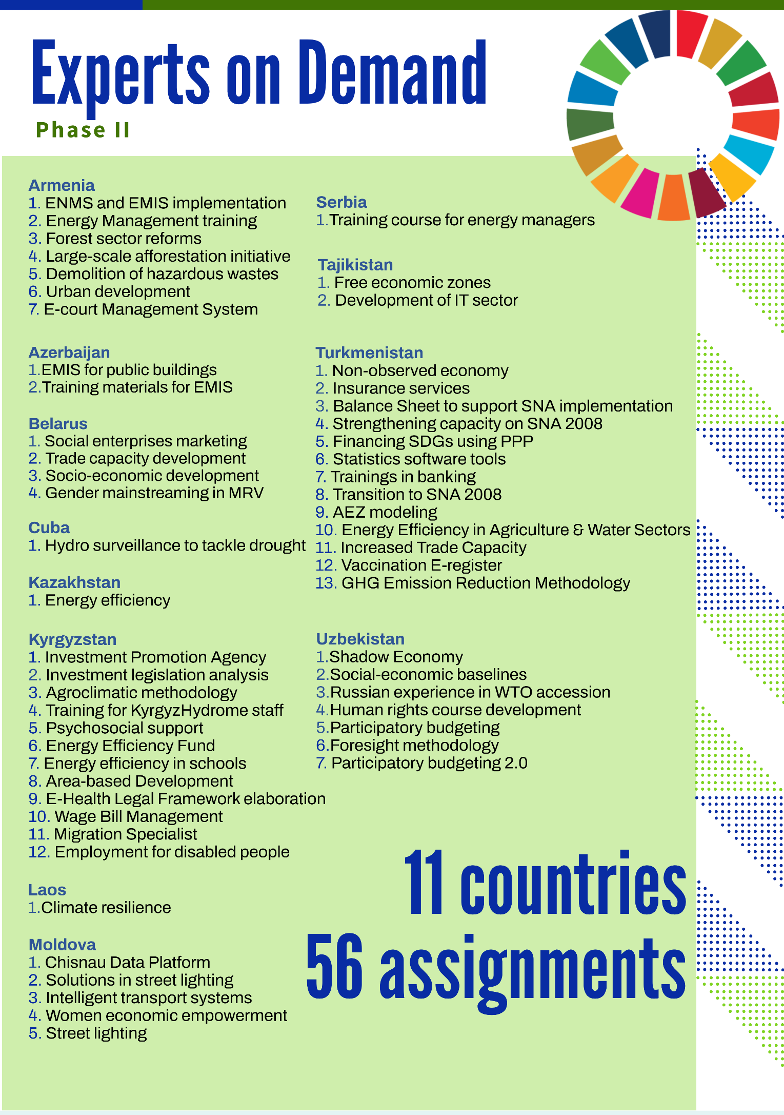
List of individual assignments completed in 2018-2021

Consultancy services will be performed online, but missions to countries could take place, if the COVID-related restrictions are lifted and travel is allowed.
Can be implemented in the format of mentorship over a period for up to 1 year.

